Name: | SRN: | Section:
Name: | Date: | Unit 2 Assignment Exercise

PROBLEM STATEMENT2 (for odd number SRNs):

TASK 1

Q1) Write a code to get the output shown below using SVG which include:
- A rectangle with rounded corners, a gradient fill and some text inside the gradient-filled rectangle.
- A polygon
- A circle with stroke
- A line

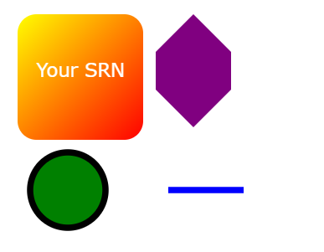

Q2) Write jQuery code to accomplish the following:

Before click
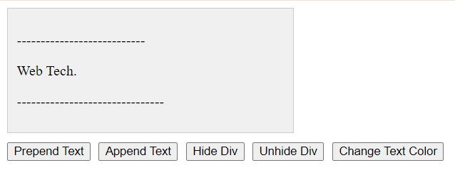

Prepend Text: Add a button that, when clicked, fades out the <div> element, prepends the text "jQuery is awesome!" to the beginning of the <div> and then fades it back in.

When the Prepend Button is clicked

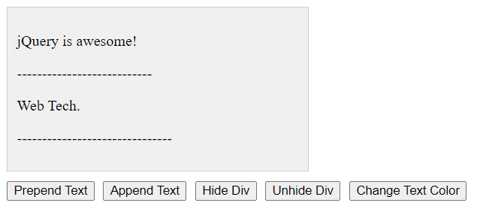

Append Text: Add a button that, when clicked, appends the text " jQuery is awesome!" to the end of the <div> element with a slide-up effect before appending.Use jQuery method chaining to achieve this.

a)Hide Div:Add a button that, when clicked, hides the <div> element with a fade-out effect.

b) Unhide Div: Add a button that, when clicked, fades out the <div> and then fades it back in to show it again. Use jQuery method chaining to achieve this.

When the Append Button is clicked
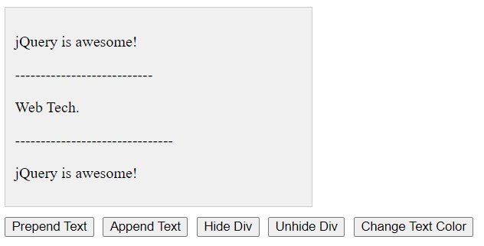

When the Hide Button is clicked

When the Unhide Button is clicked
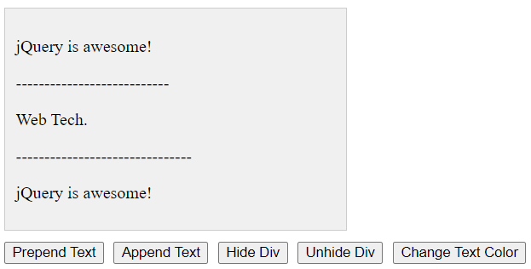

Change Text Color: Add a button that, when clicked, changes the text color of the elements with the class .filterMe inside the <div> element to a random color.

When the Change Text Color Button is clicked
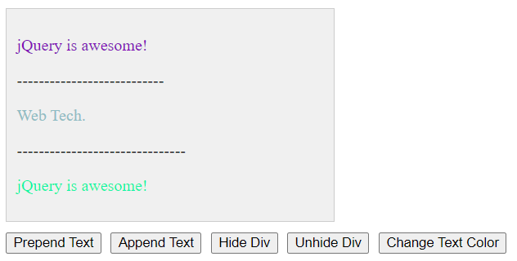

Q3) Write an HTML, CSS, and JavaScript code to create a form that submits data to a JSON placeholder API using AJAX and displays the response on the page, with a styled layout and error handling

Before :

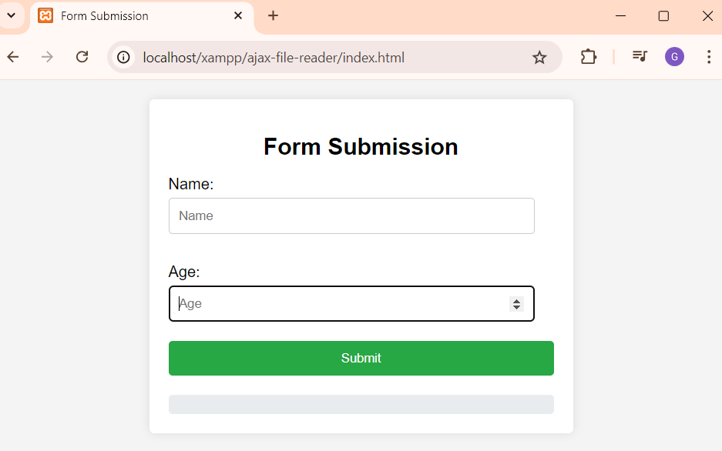

After:





